AUSTRIAN CHESS FEDERATION
Styrian Association
A-8010 Graz, Sackstraße 17
Tel. +Fax: 0043-316/877-3618, email: jugschach@aon.at, www.jugendschach.at

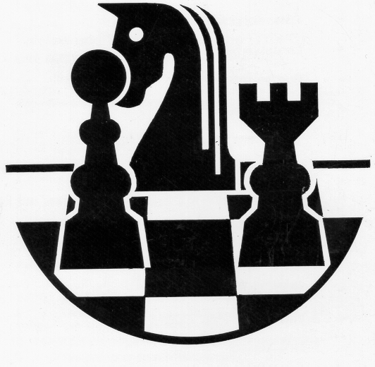

16th International Open

STYRIAN YOUTH CHESS

TOURNAMENT 8 - 17

Mureck 4 – 13 August 2009

General regulations

- Invitation
The Styrian Chess Federation in the Austrian Chess Federation has the honour of carry out
the 16th International Styrian Open Youth Chess Tournament 2009 at Mureck.

- Participation
Each Federation can enter one or more players, boy or girl in any of the categories of under 8, 10, 12, 14,
and 17 as of January 1st, 2009.

- Registration - Conditions of participation
Entry forms must be sent back not later than July 1st, 2009 by telefax or email.
Registration must mention the surname/s, first name/s, FIDE ID number, FIDE or National rating of each player. We also need the telephone, email/fax number of the delegation chief and of the person
in charge of the federation. Please use the registration form enclosed.

All travel expenses and cost for board and lodging must be paid by the participants or their National Federation.
The Registration fee of Euros 40,- has to be paid to the Organizing Committee
when registering or on arrival at Mureck.
Transport from Graz airport or Graz central station to Mureck and back will be free of charge.

4. Accommodation and meals
Board and lodging will be provided at Mureck or in its close surroundings.
The Organising Committee can accommodate participants and accompanying persons in double, or triple rooms or in apartments.
Borad and lodging is offered to players and accompanying persons
from Tuesday 4 (dinner) to Thursday 13 August (lunch).
Payments (Euros only) must be made in advance or in cash on arrival at Mureck.
The cost of lodging for all players and accompanying persons for full board per day is the following:

in double and triple rooms: 40 Euros per person
in single rooms: 49 Euros per person

Bank Account:

Bank: Steiermärkische Bank & Sparkassen AG
IBAN: AT79 2081 5075 0018 7997
BIC/SWIFT: STSPAT2G
BANK CODE: 20815
ACCOUNT NUMBER: 07500187997
BANK ADDRESS: 8480 Mureck, Hauptplatz 2
ACCOUNT HOLDER: Österreichischer Schachbund, Landesverband Steiermark

5. Tournament hall and meeting point on arrival
A-8480 Mureck, Kulturzentrum 50 km south of Graz on the Austrian-Slovenian boarder

6. Schedule
Tuesday 04 August afternoon arrival of delegations
Wednesday 05 August 14.30 opening ceremony
15.00 1st round
Thursday 06 August 15.00 2nd round
Friday 07 August 15.00 3rd round
Saturday 08 August 15.00 4th round
Sunday 09 August 15.00 5th round
Monday 10 August 15.00 6th round
Tuesday 11 August 15.00 7th round
Wednesday 12 August 15.00 8th round
Thursday 13 August 08.30 9th round
13.45 PM closing ceremony,
departure
7. Rules and regulations
The tournament will be played according to the Swiss System in 9 rounds. National ratings will not be taken into consideration for the pairings. The rate of play will be according to FIDE regulations 90 min for the whole game + 30 sec increase for each move played.

8. Chief arbiters
Manfred MUSSNIG FIDE Arbiter
Wolfgang HORVATH National Arbiter

9. Organizing Committee

Chairman Tournament director
Prof. Kurt JUNGWIRTH FM Erich GIGERL
Honorary Vice President of FIDE
President of the Austrian Chess Federation

10. Prizes
The first three players of each group will be awarded trophies.
The best girls will be awarded trophies separately.
A lot of special prices are waiting for the winners!

